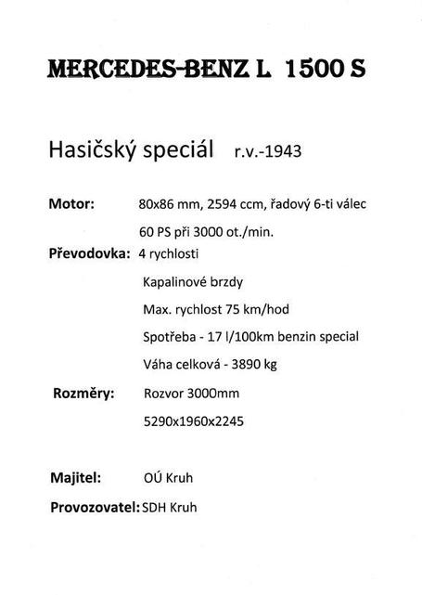

[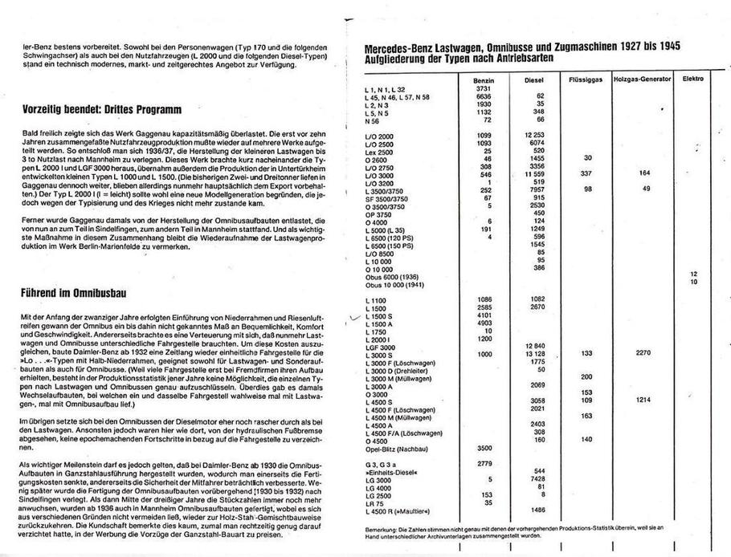](http://www.obeckruh.cz/hasici/image.php?nid=8951&oid=2828240&width=900)

## [image](http://www.obeckruh.cz/hasici/image.php?nid=8951&oid=2828241&width=900)